Dolphin GuideConnect - Touchscreen Quick Reference Guide
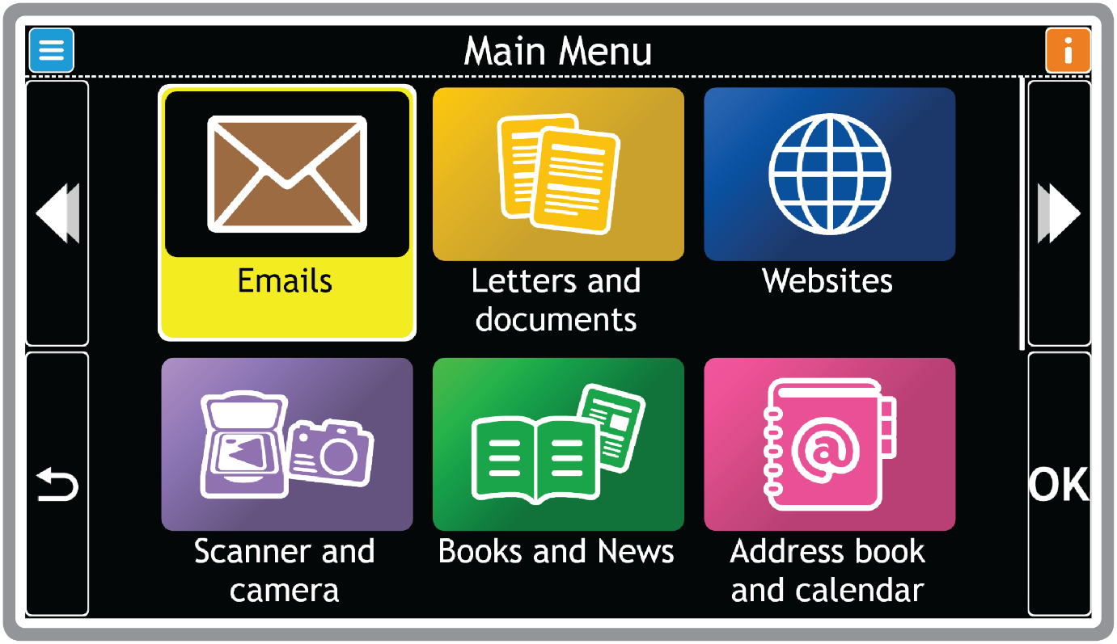

Actions (appears when available)
Previous
Go Back
Help & Info
Next
Select

For help and support contact your local Dolphin Dealer at yourdolphin.com/contact
Or browse our free resources at yourdolphin.com/support

Dolphin GuideConnect - Remote Control Quick Reference Guide
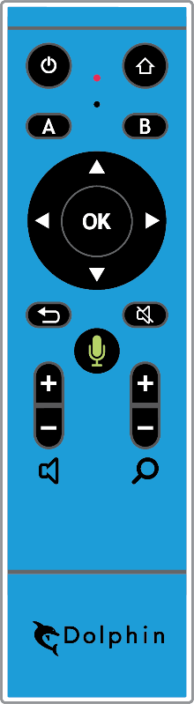
Exit Menu
Main Menu
Actions
Help & Info
Previous
Next
Select
Back
Start / Stop Reading
Voice Input – Press and hold
Volume Up / Down
Magnification Up / Down

Don’t forget to plug the small USB receiver into a USB port on your computer. You’ll find it in the box, next to the remote control. | 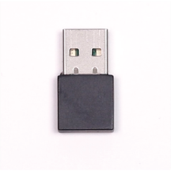

For help and support contact your local Dolphin Dealer at yourdolphin.com/contact
Or browse our free resources at yourdolphin.com/support

Dolphin GuideConnect - More Handy Keyboard Shortcuts

Shortcut keys for menus
Next item | DOWN / RIGHT ARROW
Previous item | UP / LEFT ARROW
Select item | ENTER
Back to previous screen | ESCAPE
Help | F1
Actions | F2
Help & Information | F3
Read current item | F4
Start Voice Input | F6
Interrupt speech | CTRL

Shortcut keys for writing
Next / previous word | CTRL + RIGHT / LEFT ARROW
Selecting text | SHIFT + ARROWS
Copy selected text | CTRL + C
Paste text | CTRL + V
Next / previous character | RIGHT / LEFT ARROW

Shortcut keys for reading
Next / previous line | DOWN / UP ARROW
Continuous read | F5
Pause | CTRL

Shortcut keys for websites
Next / previous item | DOWN / UP ARROW
Next / previous character | RIGHT / LEFT ARROW
Next / previous word | CTRL + RIGHT / LEFT ARROW
Turn images ON / OFF | CTRL + I
Change display mode | CTRL + T
Next heading | H
Next edit area | E
Next link | K
Back a page | BACKSPACE

Keyboard Shortcuts
Ctrl + 0 | Voice On / Off
F1 | Help
F2 | Actions menu
F3 | Help & Info
F4 | Repeat
F5 | Continue reading
F6 | Start voice input
F7 / F8 | Voice Volume:  Decrease / Increase
F9 / F10 | Voice Speed:  Decrease / Increase
F11 / F12 | Magnification:  Decrease / Increase

For help and support contact your local Dolphin Dealer at yourdolphin.com/contact
Or browse our free resources at yourdolphin.com/support

